

|  |  |  |  |  |  |  |  |  |
| --- | --- | --- | --- | --- | --- | --- | --- | --- |
|  | | | | | | | | |
|  | | Sunshine Boys | | | | |  | |
|  |  | | | | | | |  |
|  | | | |  |  | | | |
|  | | | | Gagandeep Singh Saini N01305833 |  | | | |
|  | | | | December 19, 2020—Hardware Production Tech - CENG-317-0NF—Austin Tian |  | | | |
|  | | |  | | |  | | |

**Abstract**

Sb Weather is a weather app with minimal/important functionality which is affordable and great for a new user, this product uses three main sensors. These sensors are temperature, humidity, and air pressure. The PCB will measure the data in a certain area based on the 3 sensors and store it in a database, so the app can access it. Fortunately, only the hardware side, software side needed to be working and not the database to store the information this semester. As mentioned before this project uses 3 different sensors, the sensor I am working on is temperature. Raspberry Pi 4 is used to power this project. Arduino was also a great choice, but we concluded as a group that it was a good investment for each of us to spend the money and buy a Raspberry Pi 4 with high specs, so we can use this CPU board in the upcoming years as well. When this weather product is purchased, the user will receive everything that is needed, we have made it easier for the user to use this product mainly a device is required to download the app, and everything is done automatically after that to receive the data. Thanks to the engineers at Sunshine Boys.

Table of Contents

**Abstract2**

**Introduction4**

Pictures of the app ……………………………………………………………………………………………………………..…**5**

**Proposal6**

References……………………………………………………………………………………………………………………………**6**

**Components and Brief Description**………………………………………………………………………………….**6-7**

**Individual Schematic Design**………………………………………………………………………………………………..**8**

**PCB Testing and Design9**

**Testing Results10-15**

LED …………………………………………………………………………………………………………………………………..**10**

Detecting Sensor….………………………………………………………………………………………………………………**11**

Temperature Sensor Normal Use.………………………………………………………………………………………….**11**

Temperature Sensor Under Load………………………………………………………………………………………….**12**

LED Code……………………………………………………………………………………………………………………………**13**

TMP102 Code………………………………………………………………………………………………………………..**14-15**

**Conclusion15**

**GitHub Link for the app**………………………………………………………………………………………………………**15**

**Introduction**

This product uses three sensors for each member of the team. The sensors in more detail are the TMP102 temperature sensor, DPS310 air pressure sensor, and DHT22 humidity sensor. These sensors can do more than just what they are used for now, it was decided not to measure any other data to bring down the cost of the product, since this is an entry-level product for beginners. All the components used on the PCB are through hole which are soldered on. A LED was also added right on the board so a user can test the product in case something is wrong, and it will be easier for the team at Sunshine Boys to troubleshoot as well, over the phone or email. Moving on, the PCB was ordered on SeeedStudio, which was an amazing choice since the delivery time was not long. That was some information about what we have done in our hardware class (CENG 317). Let us move on to Software class (CENG 319). After many suggestions, we have decided to name our app Sb Weather since our company is called Sunshine boys. This app uses firebase to store the login information, so decisions were made to make firebase our primary source to store the sensor’s data as well. It is always less confusing when everything is in one place and maybe later, firebase will be able to offer better prices since many of their features are used in this project (sponsorship), considering this small weather company is just starting out. The Sb weather app has three tabs for the PCB board information, which will show the temperature, humidity, air pressure of a city. For example, Toronto as you can see in the picture below, this data is pulled with a weather API, it will also show the data of where you place it, and lastly, the graph tab which includes the data in the past 5 days up to a month into a graph format. As of now, the data is being simulated by a weather API, this will change next semester.

**Pictures of the app**

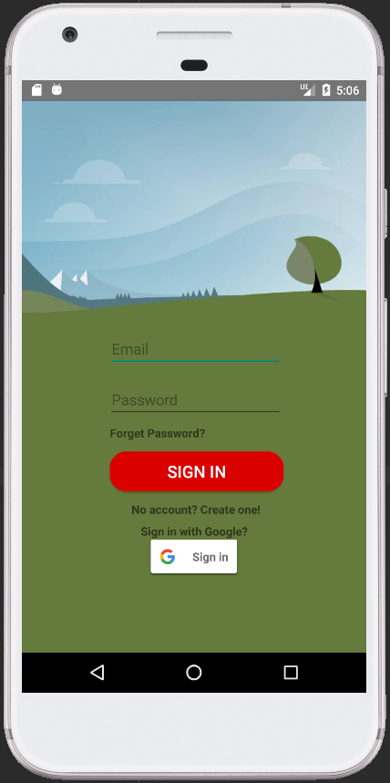 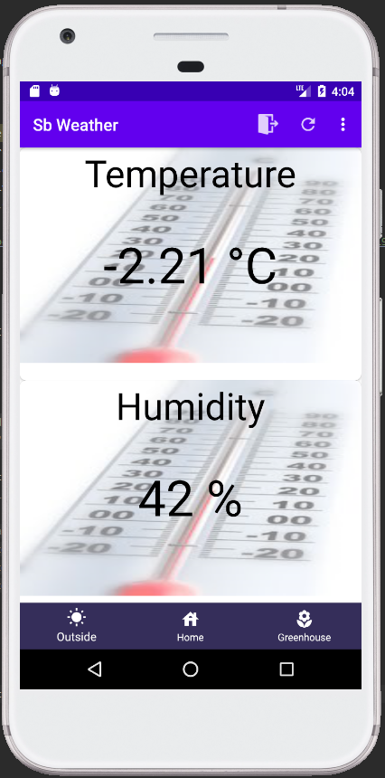

**Proposal**

Firstly, when the teams were formed, Robert was part of this group (a group of 4), but as the semester went on, he ended up dropping the course so now the team consist of 3 members, but Robert is still part of our software project app. During this proposal, Robert’s name will come up, yet disregard that since this is an original proposal with minor changes. The infrastructure was moved from 4 sensors to 3.

Sunshine boys is a company, which consists of Jeremy who will be working on the humidity sensor, Nathan will be working on the Barometer (Air Pressure sensor). Robert will be working on wind speed

I will be working on the temperature sensor. The things we will be measuring are temperature, humidity, wind speed, Air pressure sensor. Our project will consist of many sensors, codes that will help to measure atmospheric conditions in the area you use it in. Some of the sensors we are using include temperature, Humidity, and air pressure.

For my CENG 317 I will be working on the temperature sensor and using a raspberry pie. I will buy the PCB board from the website that was shown in class (Seeed Studio). The board will take 1 month and soldering will take 1 class, but I will be done in time, I can't give an estimated time because it depends on the PCB board and how long it takes to come but I hope to be done before week 8, if there's a problem I will ask the prof for help, if it's not resolved I will submit it late, I will decide that when the time comes.

I am sure there are many projects like mine, but my is way simpler for everyday use and shows only the things everyday people would need, which makes it cheaper. For example, our project only shows temp, humidity, wind speed while other projects on the market show way more, for example, leaf wetness, soil moisture, going back to my point(conclusion) everyday people do not need stuff like that and most importantly it brings the price down.

**References:** This project is like ours, but also more complex. https://shoponset.hoskin.ca/products/hobo-u30-nrc-weather-station-starter-kit?variant=42959184016

**Components and breif description**

Here are the materials that were used on the PCB board, to create what was achieved.

* TMP 102 Sensor
* One 330 Ω Resistor
* One 56k Ω Resistor
* Red LED
* NPN Transistor
* 2x20 GPIO Header for Raspberry Pi
* 2x20 GPIO Ribbon Cable
* 6 Pin Male to Female Header
* 6 Pin Right Angle Male to Male Header
* Raspberry Pi 4 Model B

Tmp102 is a temperature sensor. Some temperature sensors use an analog voltage to represent the temperature, but this sensor uses the I2C bus of the Raspberry Pi to communicate the temperature. I2C busses being SDA and SCL. When the sensor is plugged in, it runs on the address 0x48 by default.

This sensor has two voltage options to connect to, so a 3.3V port was used to connect the PCB to the Raspberry Pi. Tmp102 uses drain signaling so the level shifting is not needed. It has a built-in 4.7K Ω pull-up resistor and it is accurate by 0.5°C from -25° to +85°C. This sensor has 6 ports, but only 4 ports were used. The ports “ALT” and “ADD0” were not needed since ALT is a warning(ALERT) function which was not implemented on this project yet, the temperature will not go that high, at least that’s how our team at Sunshine Boys feel, but the users can use it however they would like, but it is not recommended for very high or low temperatures. ADD0 port is used to change the address, but the address is different for all the sensors for Sb weather’s product, so this port is never used either. Moving on to the red LED, this is used to troubleshoot and to see if the Raspberry Pi is working(Gpio). Also, an NPN transistor was used to control the current/voltage going to the LED, since 3.3V was not needed running throughout the PCB. Next, The 2x20 headers and ribbon cable were used to connect the Pi to the PCB and the six pins headers were used to connect the sensor to the PCB through soldering. Furthermore, Raspberry Pi Model B was used to bring everything to life, with the help of 8Gb RAM and many other components this CPU board has.

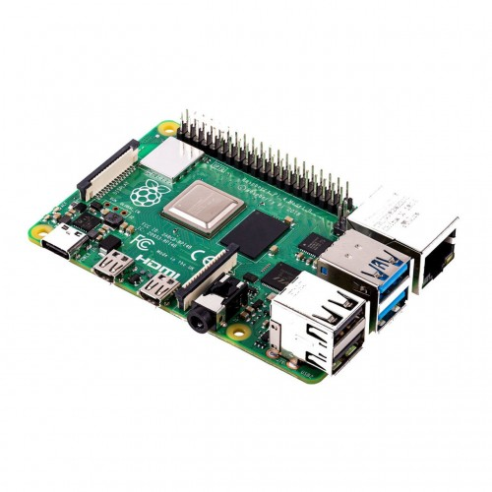 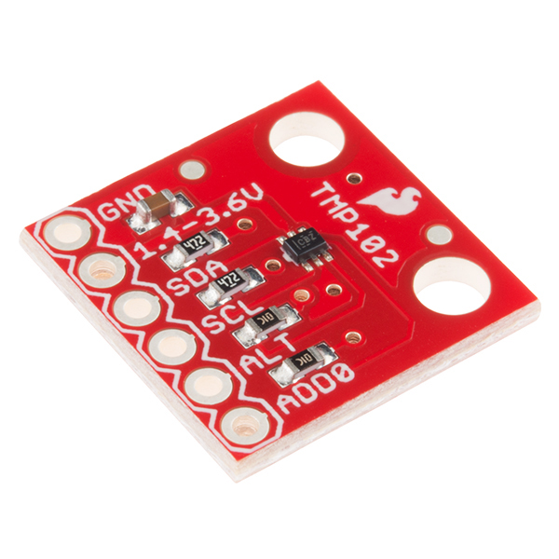

**Individual Schematic Design**

These are the early stages of the temperature sensor project. It all started out with an illustration of how it would all connect as seen in the picture. This gives a better description of where some of the components are used and how they interact with each other. For example, where the voltage starts, how it goes through the circuit, and where it gets destroyed(grounded). “Part 1” is the TMP102 sensor, “JP1” is the 6 pin header soldered on the PCB, “Q1” is NPN transistor and “R1, R2” are simply just resistors. Netlabels are just which are wires basically, but they clean the circuit so its more readable. Why does this product use 330 and 56k Ω resistors? A lot of testing was done through multisim with many different resistors to find the perfect match which would give the brightest LED without burning it.

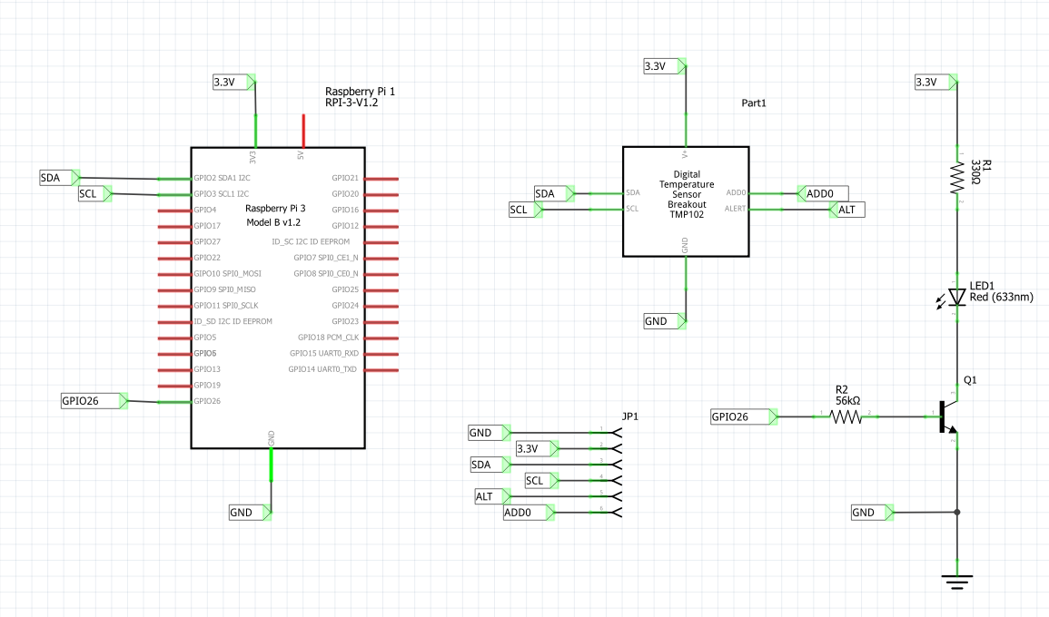

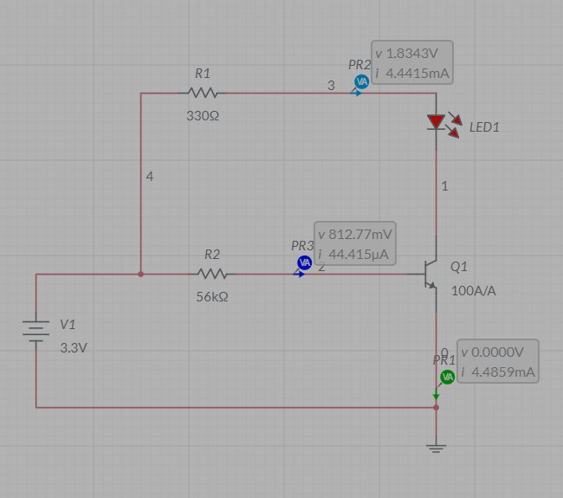

**PCB Testing and Design**

After everything is connected in the Schematic phase, this is where the locations of the components are selected. Yellow wires run on top and orange wires at the bottom, this is to keep them from overlapping and shortcircuiting the circuit or worse. When everything was soldered on this is where the testing began. Before the PCB was turned on, the resistance was measured throughout the PCB circuit(power to the ground) which seemed fine. Secondly, Raspberry Pi was connected, i2c had to enabled and new tools needed to be installed after all this was done, the i2cdetect command was used to see if the sensor was detected which also seemed fine. At this point, 2 files were created with the appropriate code and permissions, file names were LED.py, tmp102.py, and both files were run one at a time starting with the LED.py, then the Tmp102.py. The PCB responeded to these commands and displayed the correct information.

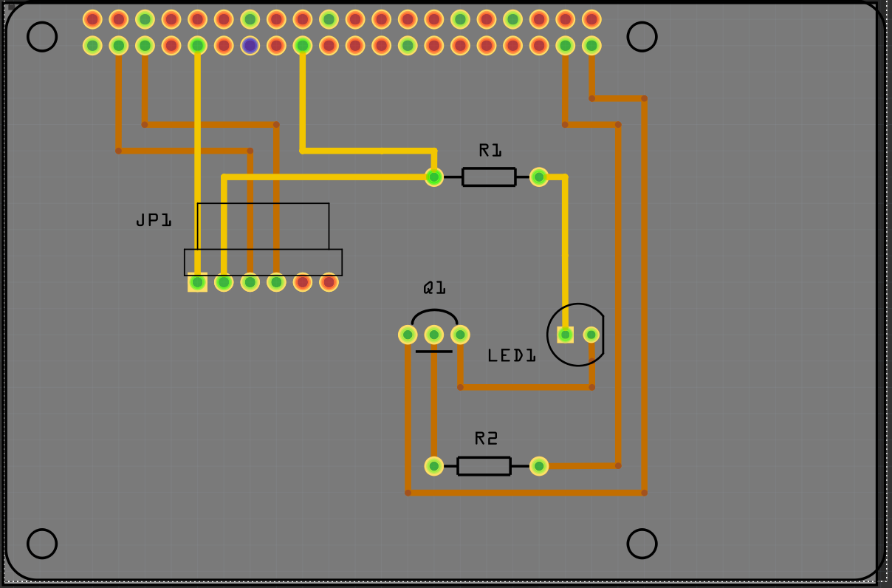

**Testing Results**

Everything is working and here are the results with the code.

**LED:**

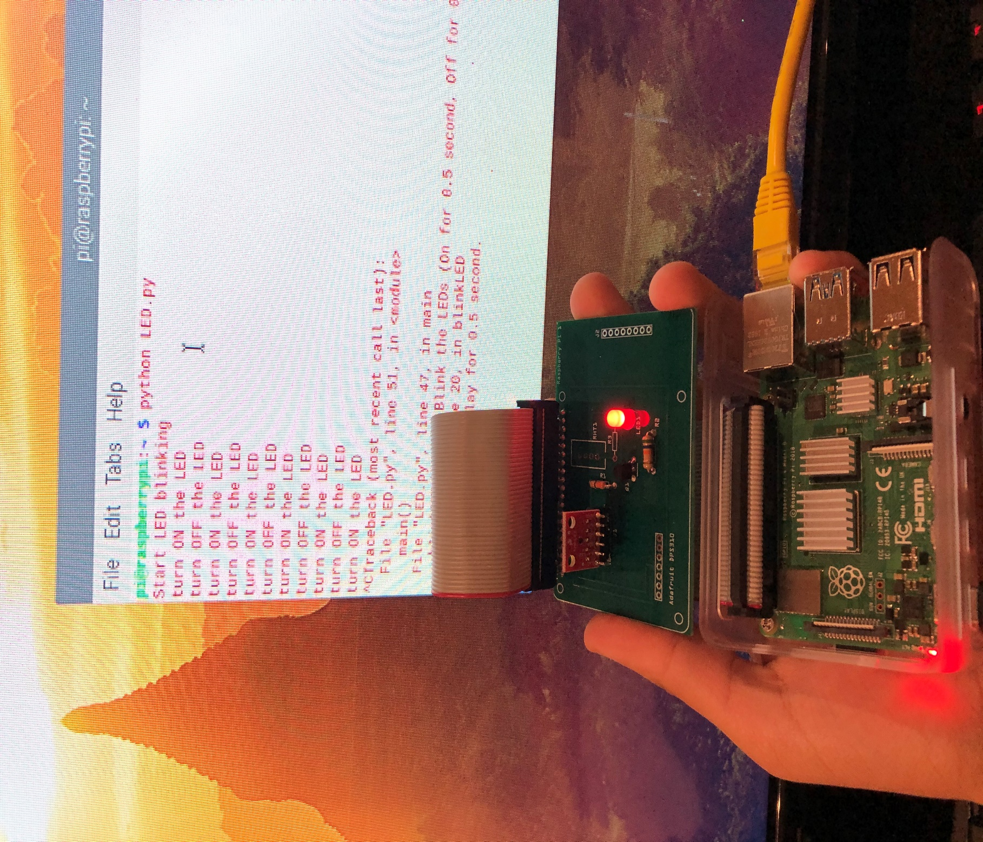

**Detecting Sensor:**

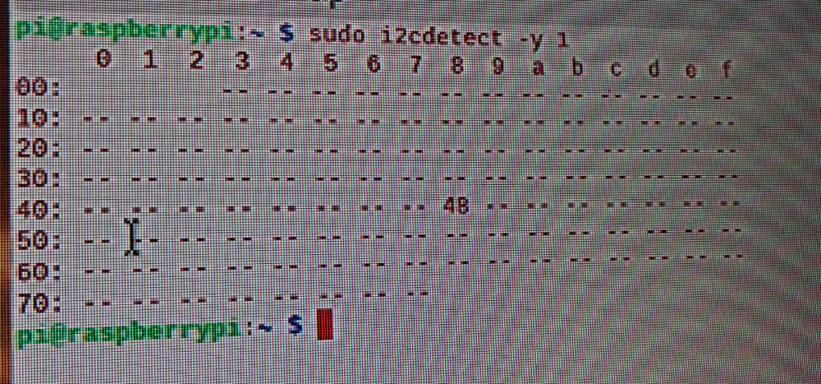

**Temperature Sensor Normal Use:**

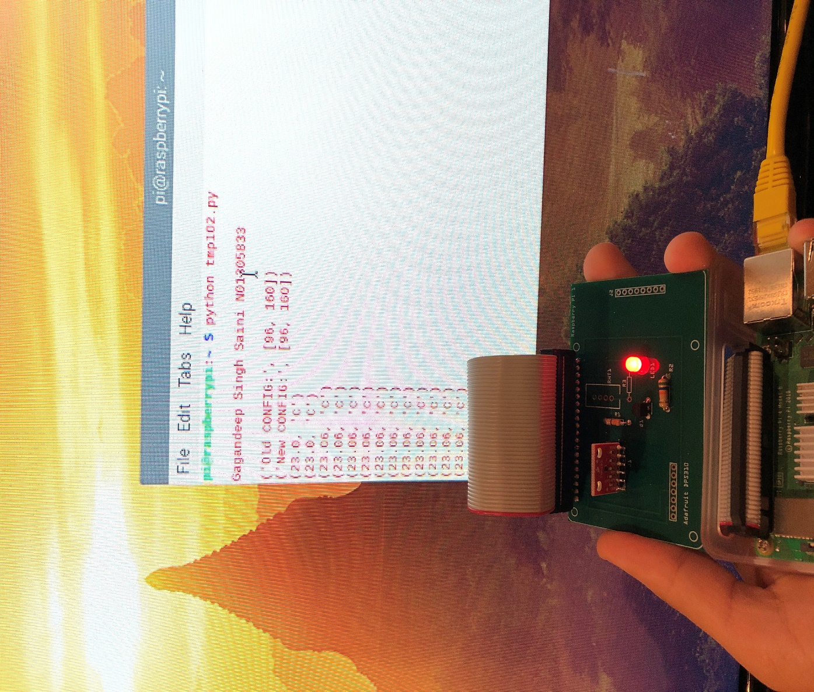

**Temperature Sensor Under Load:**

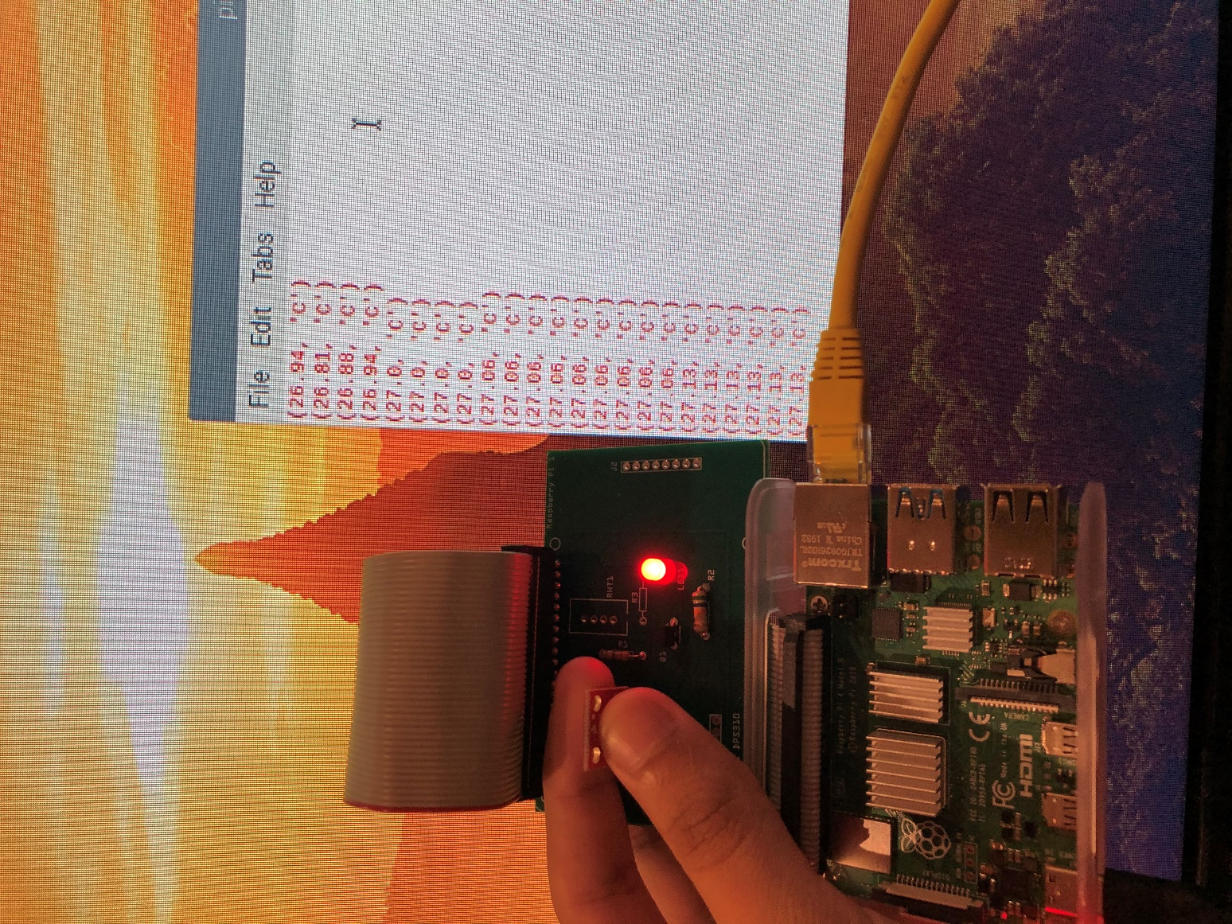

**LED Code:**

#!/usr/bin/python3

import sys

import os

from time import sleep

try:

import RPi.GPIO as GPIO

except RuntimeError:

print("Error importing RPi.GPIO! This is probably because you need superuser privileges. You can achieve this by using 'sudo' to run your script")

PIN_18=26 #GPIO18 -- this LED is driven by GPIO 18.

PIN_17=17 #GPIO17 -- as another example.

GPIO_Out_List=[PIN_17,PIN_18]

def blinkLED():

i = 0;

for i in range (0, 1000): # repeat 1000 times.

turnon()

sleep(0.5) # delay for 0.5 second.

turnoff()

sleep(0.5) # delay for 0.5 second.

i+= 1

return

def turnoff():

GPIO.output(PIN_18, GPIO.LOW) # Turn OFF the LED connected to GPIO 18.

print ('turn OFF the LED')

return

def turnon():

GPIO.output(PIN_18, GPIO.HIGH) # Turn ON the LED connected to GPIO 18.

print ('turn ON the LED')

return

def main():

global PIN_17

global PIN_18

global GPIO_Chan_List

print ('Start LED blinking')

GPIO.setmode(GPIO.BCM) # use this BCM (Board GPIO number) instead of using Board Pin numbers.

GPIO.setwarnings(False)

GPIO.setup(GPIO_Out_List, GPIO.OUT) #Initialize the Channel List PIN_17 and PIN_18 as outputs.

blinkLED() # Blink the LEDs (On for 0.5 second, Off for 0.5 second)

if __name__ == "__main__":

main()

**TMP102 Code:**

import time

import smbus

i2c_ch = 1

# TMP102 address on the I2C bus

i2c_address = 0x48

# Register addresses

reg_temp = 0x00

reg_config = 0x01

# Calculate the 2's complement of a number

def twos_comp(val, bits):

if (val & (1 << (bits - 1))) != 0:

val = val - (1 << bits)

return val

# Read temperature registers and calculate Celsius

def read_temp():

# Read temperature registers

val = bus.read_i2c_block_data(i2c_address, reg_temp, 2)

# NOTE: val[0] = MSB byte 1, val [1] = LSB byte 2

#print ("!shifted val[0] = ", bin(val[0]), "val[1] = ", bin(val[1]))

temp_c = (val[0] << 4) | (val[1] >> 4)

#print (" shifted val[0] = ", bin(val[0] << 4), "val[1] = ", bin(val[1] >> 4))

#print (bin(temp_c))

# Convert to 2s complement (temperatures can be negative)

temp_c = twos_comp(temp_c, 12)

# Convert registers value to temperature (C)

temp_c = temp_c * 0.0625

return temp_c

# Initialize I2C (SMBus)

bus = smbus.SMBus(i2c_ch)

# Read the CONFIG register (2 bytes)

val = bus.read_i2c_block_data(i2c_address, reg_config, 2)

print("\nGagandeep Singh Saini N01305833\n")

print("Old CONFIG:", val)

# Set to 4 Hz sampling (CR1, CR0 = 0b10)

val[1] = val[1] & 0b00111111

val[1] = val[1] | (0b10 << 6)

# Write 4 Hz sampling back to CONFIG

bus.write_i2c_block_data(i2c_address, reg_config, val)

# Read CONFIG to verify that we changed it

val = bus.read_i2c_block_data(i2c_address, reg_config, 2)

print("New CONFIG:", val)

# Print out temperature every second

while True:

temperature = read_temp()

print(round(temperature, 2), "C")

time.sleep(1)

**Conclusion**

In conclusion, I’ve accomplished what I wanted, which was to get this project working and mainly without any problems. The Sb Weather app is also done and ready to be linked with this hardware project, now the only challenge is to find how the data would be sent to the database and pulled to the app which will be done next semester. During this course, the first and the important thing I learned is that, the finished product needs to be tested before it’s plugged into the power, if issues arise it will not short circuit the design. If it wasn’t for the professor providing the “testing of the circuit” document I would have done exactly this. Secondly, go in steps while testing.

**GitHub Link for the app**

This github link is for the app (software project), which includes the code, etc. For hardware class github was not made because it was not required and did not need.

https://github.com/NatHed/Sunshine-Boys-Project/tree/master/Sunshine%20Boys